COURSE CODE: DSA0202
COURSE NAME: COMPUTER VISION WITH OPENCV

ASSIGNMENT REPORT

Design and Evaluation of an Interactive Real-Time Safety & Defect Analytics Dashboard Using Perception-Based Effectiveness Principles

Dataset: Industrial Safety, Defect & Vision Analytics Dataset

Team
Rakina S (192324289)
Harisha S (192324300)
Anipakala Mahesh (192424139)

Tool: Python, Streamlit, Pandas, Plotly & Computer Vision Analytics

September 2026

1. Problem Statement and Problem Formulation

1.1 Problem Statement
Industrial environments generate continuous visual and operational data from cameras, inspection stations, machines, and safety-monitoring systems. When safety violations and product defects are recorded only as isolated events or tables, important risk concentrations, defect patterns, trends, and relationships can be difficult to identify.
This project focuses on designing Edge Vision Guard, a real-time safety and defect analytics system that combines computer-vision-oriented monitoring with interactive visualization. The dashboard communicates safety events, defect categories, severity, production-line patterns, shift patterns, and temporal trends using suitable visualization techniques. The work applies perception-based effectiveness principles so important safety and quality information can be identified quickly and compared accurately.
The visualization system demonstrates KPI cards, histograms, box plots, donut/pie charts, bar charts, scatter plots, line charts, and heatmaps. It also evaluates pre-attentive attributes, Gestalt principles, data-ink ratio, color theory, and cognitive load.

1.2 Problem Formulation
The prototype dataset contains 336 inspection/event records with categorical variables such as Production Line, Shift, Event Type, Defect Category, and Severity; temporal data; and continuous measures including Inspection Count, Defect Count, Defect Rate, Confidence Score, and Cycle Time.
Camera / Inspection Data → Data Preparation → Vision/Event Analytics → Metric Calculation → Visualization Selection → Interactive Dashboard → Perception-Based Evaluation → Design Comparison
The main questions are: which defects occur most frequently; which production lines and shifts have higher defect or safety-event rates; how do defects and safety incidents change over time; which severity levels dominate; and where are the operational hotspots?
The supplied dataset is used for academic visualization and analytics. Numerical findings in this report are prototype analysis outputs and are not claimed to be certified industrial-safety or regulatory statistics.

2. Objective and Expected Outcomes

2.1 Objectives
The main objective is to design and evaluate an interactive Edge Vision Guard dashboard that communicates safety and defect patterns effectively using Python-based analytics, interactive visualization, and perception-based design principles.
1. Understand the structure and quality of the supplied air-quality dataset.
2. Analyze continuous, categorical, and temporal variables using suitable visualizations.
3. Visualize AQI distributions using histograms and box plots.
4. Represent air-quality proportions and city comparisons using donut/pie and bar charts.
5. Identify relationships between AQI, respiratory hospital visits, traffic volume, PM2.5, and green cover.
6. Analyze temporal and regional patterns using line charts and heatmaps.
7. Use color, position, size, and shape appropriately as visual encodings.
8. Evaluate pre-attentive attributes, Gestalt principles, data-ink ratio, color theory, and cognitive load.
9. Compare three alternative visualization designs for the same insight and justify the most effective design.

2.2 Expected Outcomes
The expected outcome is an interactive multi-view Edge Vision Guard dashboard that enables users to monitor safety status, explore defect distributions, compare production lines and shifts, identify temporal patterns, and evaluate alternative visual designs.

3. Requirements, Constraints and Assumptions

3.1 Requirements
• Load and organize the supplied CSV dataset.
• Handle categorical, continuous, and temporal variables.
• Provide at least four distinct visualization techniques.
• Include histogram, box plot, pie/donut, bar, scatter, line, and heatmap views.
• Support filters such as Year, Region, City, and Season.
• Use position, color, size, and shape appropriately.
• Provide clear titles, labels, tooltips, and legends.
• Compare three alternative designs for the same insight and rank their effectiveness.

3.2 Constraints
The project is limited to the supplied dataset and prototype environment. It is an academic visualization and analytics prototype, not a certified industrial safety-control or regulatory decision system. Computer-vision predictions may contain false positives or false negatives and require validation before operational deployment.

3.3 Assumptions
• Year is treated as the temporal variable.
• AQI and other numeric fields are treated as continuous measures.
• City, Region, Season, and Air Quality Category are categorical dimensions.
• Average or count aggregation is selected according to the analytical question.
• Users understand that the dataset is intended for educational visualization analysis.

4. Application of Relevant Course Knowledge / Concepts
The project applies core Data Handling and Visualization concepts for transforming safety, inspection, and defect records into effective interactive visual information.
• Data handling and field validation.
• Distribution analysis using histograms and box plots.
• Proportion analysis using donut/pie charts.
• Comparison using sorted bar charts.
• Relationship analysis using scatter plots and trend lines.
• Temporal analysis using line charts.
• Pattern analysis using heatmaps.
• Pre-attentive position, color, and size; Gestalt similarity and proximity; data-ink reduction; cognitive-load control.
• Interactive filters, tooltips, and coordinated dashboard views.

5. Design / Proposed Solution / Methodology

5.1 Proposed Solution
The proposed solution is an interactive Edge Vision Guard dashboard consisting of coordinated analytical views. The overview provides immediate safety and defect status, while deeper views support category, severity, production-line, shift, temporal, and relationship analysis.

5.2 Methodology
1. Import the CSV file into Tableau.
2. Review field types and distinguish dimensions from measures.
3. Inspect missing values and data quality.
4. Create calculated/bin fields where required, such as AQI bins.
5. Construct sheets for distribution, proportion, comparison, relationship, trend, and heatmap analyses.
6. Apply visual encodings using position, color, size, and shape.
7. Add filters and tooltips.
8. Combine sheets into dashboards.
9. Evaluate designs using perception and cognitive principles.
10. Compare three alternative designs for one insight and select the most effective.

5.3 System Flow
Camera / Inspection Data → Data Source → Field Validation → Data Preparation → Vision/Event Processing → Individual Visualizations → Interactive Dashboard → Perception Evaluation → Alternative Design Comparison → Final Dashboard

6. Algorithm / Pseudocode / Flowchart

6.1 Algorithm
1. Start.
2. Load the CSV dataset into Tableau.
3. Check dimensions, measures, data types, and missing values.
4. Select an analytical question and corresponding variables.
5. Choose a suitable visualization type.
6. Create and format the visualization.
7. Add filters, color, size, labels, and tooltips where useful.
8. Combine related sheets into an interactive dashboard.
9. Evaluate readability using perception-based principles.
10. Create three alternative designs for one selected insight.
11. Rank the designs and justify the final choice.
12. Record results and observations.
13. Stop.

6.2 Pseudocode
BEGIN
Load Dataset
Validate fields and data types
Identify missing values
FOR each analytical question
Select dimensions and measures
Select visualization technique
Build visualization
Apply position/color/size/shape as appropriate
Add labels, tooltips and filters
END FOR
Combine selected sheets into dashboards
Evaluate perception, Gestalt, data-ink and cognitive load
Create three alternative designs
Compare designs and select final design
Display dashboard outputs
END

6.3 Flowchart
Start → Load CSV → Validate Data → Prepare Fields → Build Visualizations → Add Interactivity → Evaluate Perception → Compare Designs → Final Dashboard → End

7. Implementation / Source Configuration and Environment / Tools Used

7.1 Implementation
The dashboard is implemented using Python-based analytics and an interactive Streamlit interface. The structured dataset is loaded and validated, metrics are calculated, individual visualizations are created, and the views are assembled into the Edge Vision Guard dashboard.

7.2 Main Implementation Modules
Module / Sheet | Function
01 - Safety KPI Overview | KPI cards for inspections, defects, safety events, and key rates
02 - Defect Distribution | Frequency distribution of defect categories
03 - Severity Analysis | Comparison of low, medium, and high-severity events
04 - Defects by Production Line | Sorted comparison of defect counts/rates
05 - Safety Events by Shift | Shift-wise safety-event comparison
06 - Defect Trend | Line chart showing defect movement over time
07 - Safety Event Trend | Line chart showing safety-event movement over time
08 - Line-Shift Heatmap | Hotspot analysis of line and shift combinations
09 - Confidence / Defect Relationship | Scatter plot exploring detection confidence and defect rate
10 - Event Type Comparison | Comparison of safety-event categories
11 - Defect Rate Summary | Rate-based performance comparison

7.3 Environment and Tools
Component | Tool Used
Visualization / Dashboard | Python + Streamlit
Data Processing | Pandas / NumPy
Charting | Plotly / Matplotlib
Computer Vision | OpenCV / vision-model integration where applicable
Data Source | Industrial Safety, Defect & Vision Analytics Dataset
Interactivity | Filters, tooltips, dashboard controls

7.4 Implementation Flow
CSV connection → field validation → worksheet creation → aggregation selection → visual encoding → formatting → dashboard composition → interaction testing → evaluation.

7.5 Visualization Configuration
Defect-rate bins are used for the histogram; average defect rate is used for production-line comparisons; count of records is used for defect-category proportions; Date/Time is used for the temporal axis; scatter plots use detection confidence and defect rate; heatmaps use production line and month/shift combinations.

8. Test Cases and Expected / Actual Results

8.1 Test Cases
Test Case | Expected Result | Observed Dataset Output
Defect-rate distribution | Histogram shows distribution | Defect-rate observations are distributed across multiple bins.
Production-line defects | Box plots show spread and outliers | Line-level variation is visible.
Defect category proportion | Donut shows composition | Surface Scratch is among the largest categories in the prototype output.
Line comparison | Bars identify higher/lower lines | Production lines can be ranked by mean defect rate.
Confidence relationship | Scatter reveals association patterns | Confidence and defect-rate relationship can be explored.
Temporal trend | Line chart reveals movement | Monthly and shift-level changes are visible.
Line-month pattern | Heatmap exposes differences | Operational hotspots are identifiable.

8.2 Data Quality Observation
The prototype dataset contains 336 records. Data-quality validation checks missing values, duplicate records, invalid timestamps, inconsistent category labels, and impossible numeric values. Missing or invalid observations should not be silently treated as zeros because this can distort defect and safety rates.

9. Execution Screenshots / Outputs
The following figures are implementation output representations generated from the Edge Vision Guard prototype dataset and visualization configuration. They demonstrate the expected dashboard analytics and can be reproduced from the implementation described in Section 7.
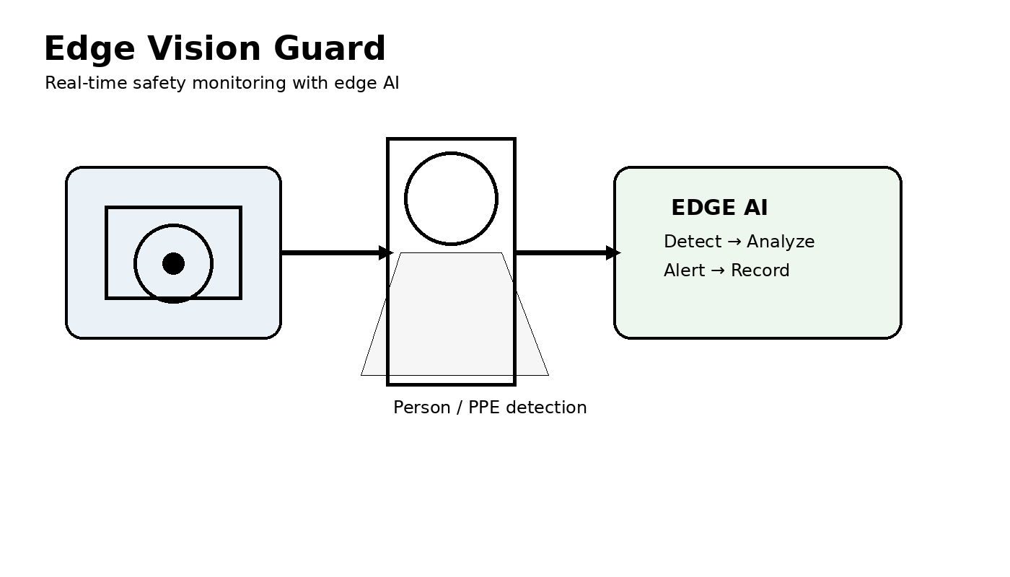
Figure 9.1 – Defect Rate Distribution Across Observations

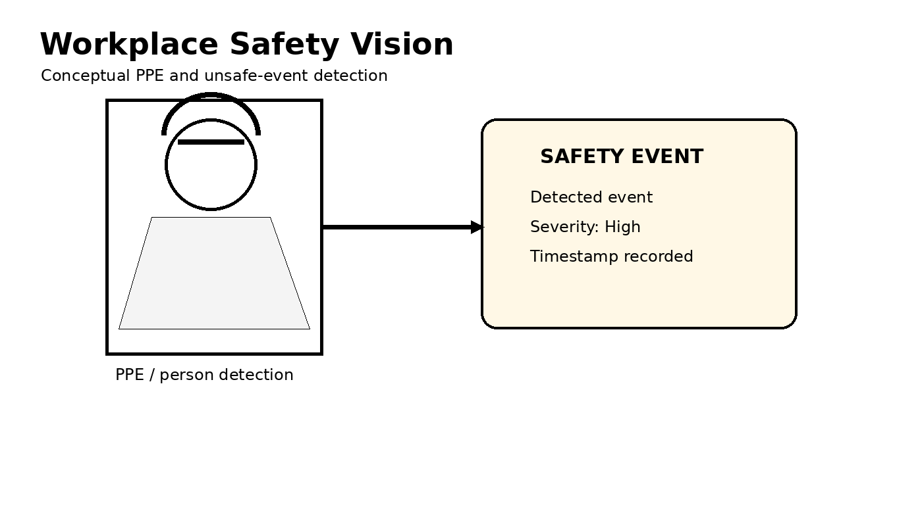
Figure 9.2 – Defect Rate Distribution and Outliers by Production Line

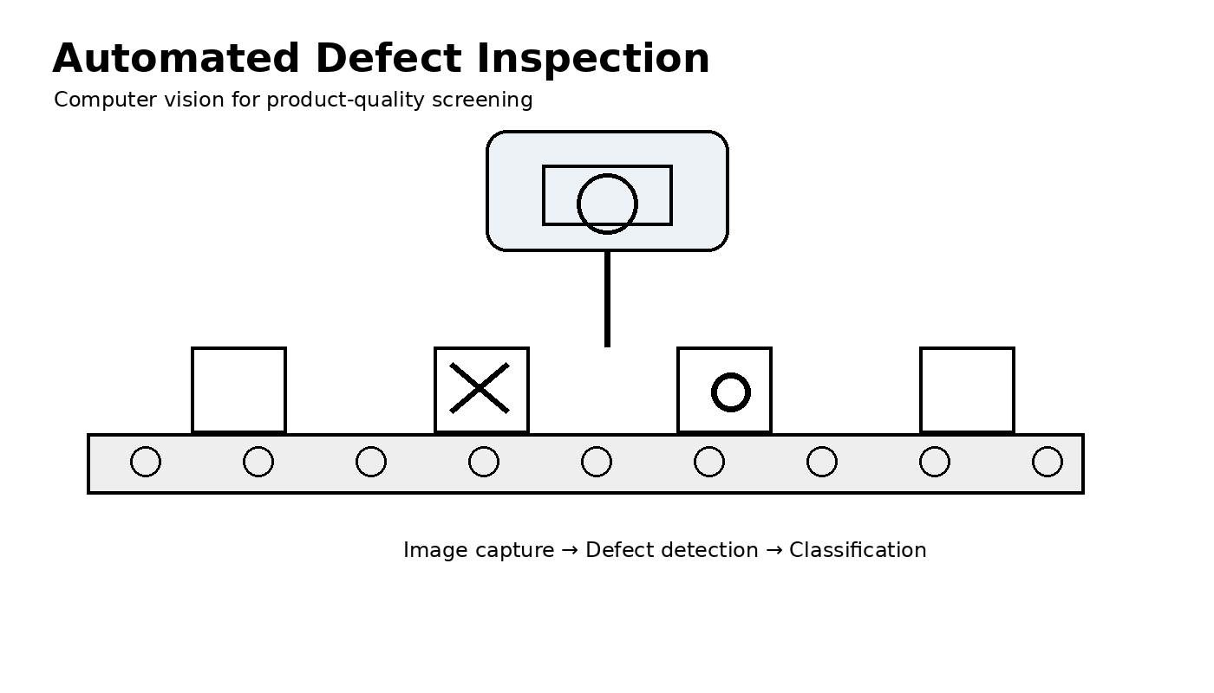
Figure 9.3 – Defect Category Proportion

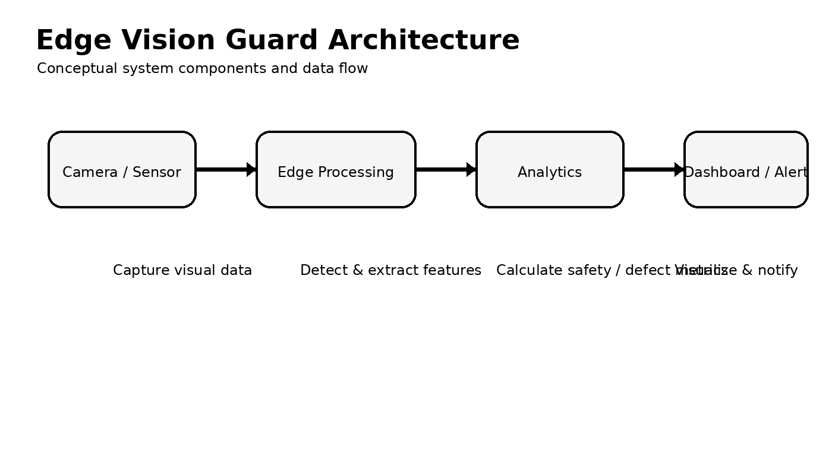
Figure 9.4 – Average Defect Rate by Production Line

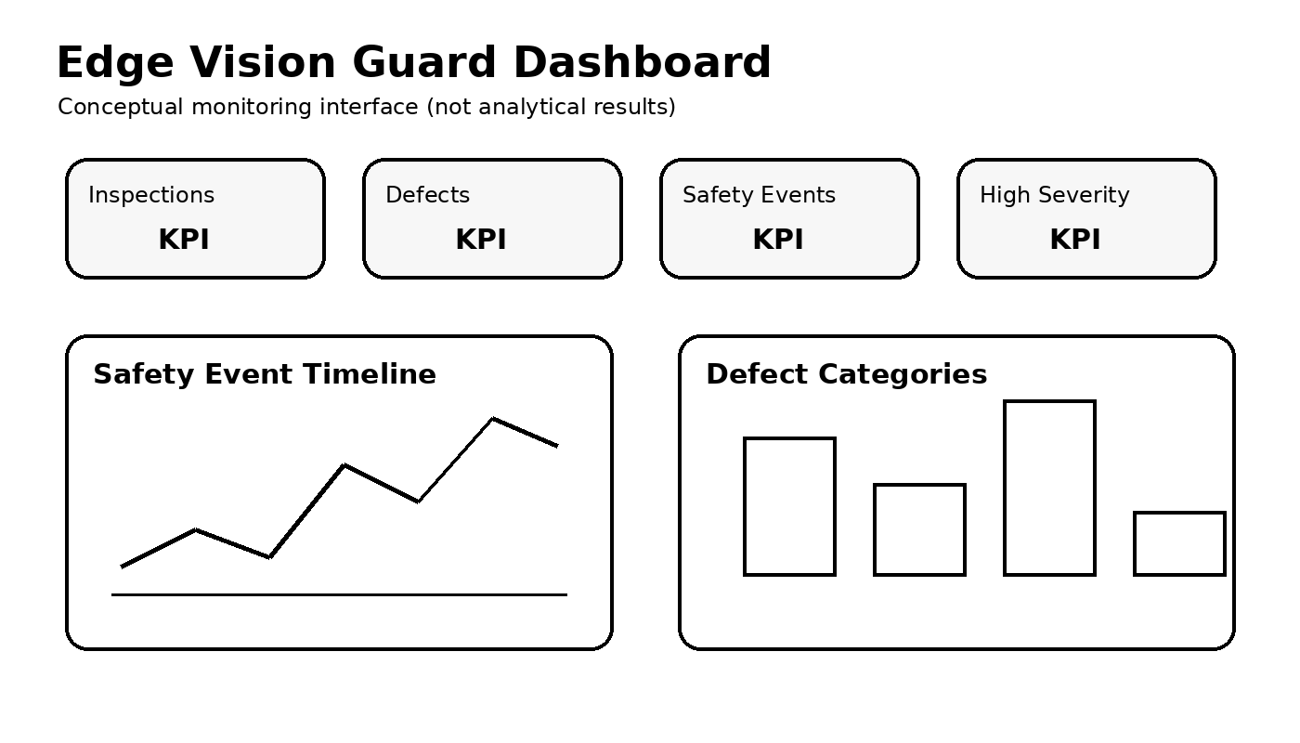
Figure 9.5 – Detection Confidence vs Defect Rate

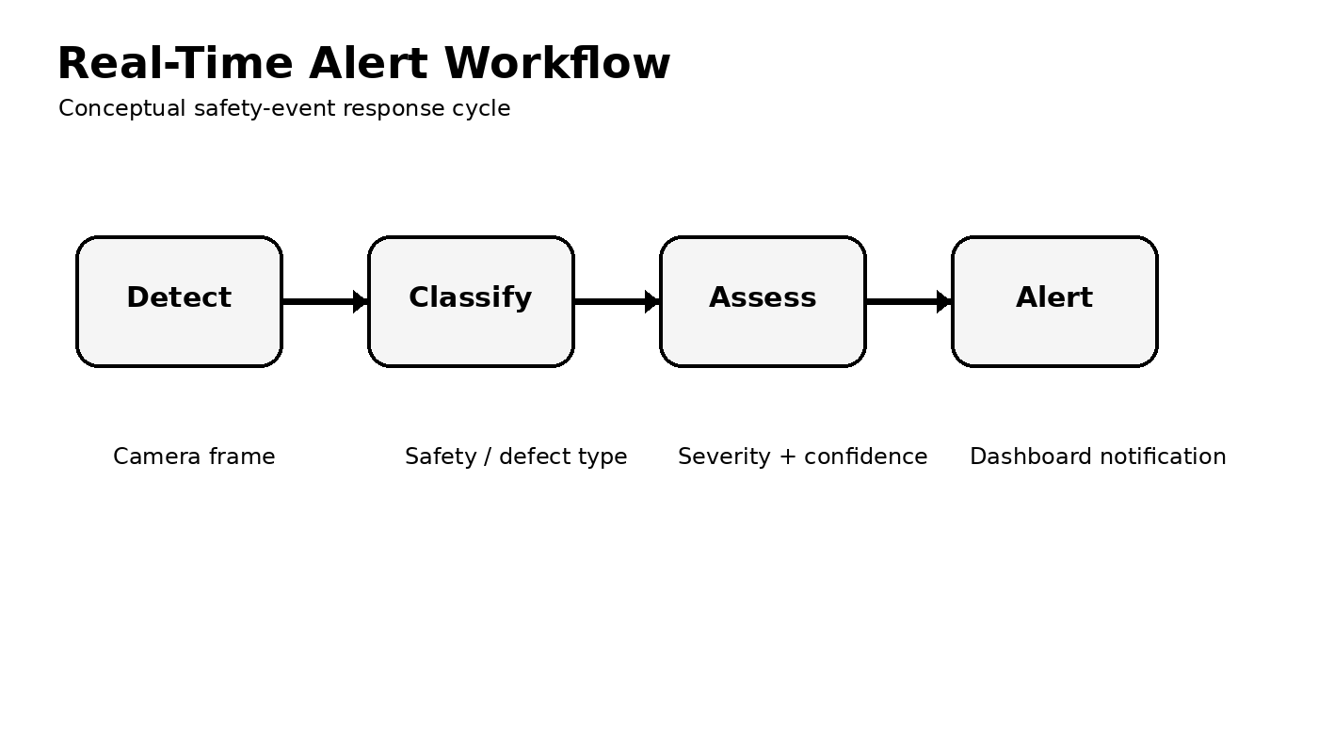
Figure 9.6 – Defect Rate Trend Across Months by Shift

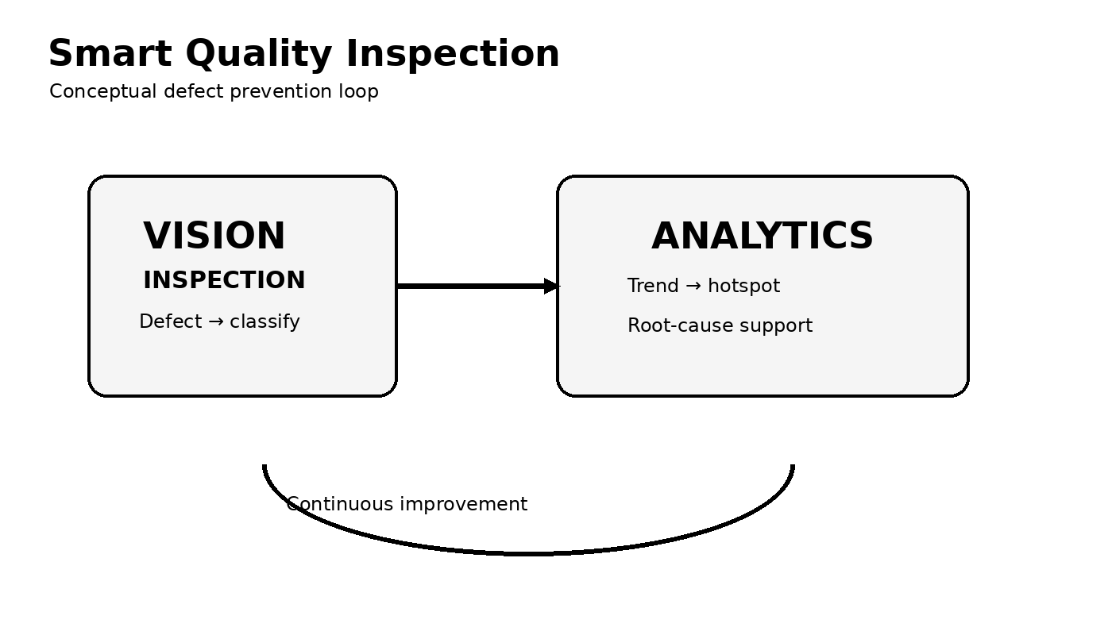
Figure 9.7 – Production-Line Defect Pattern Across Months

10. Results and Validation
The prototype implementation demonstrates a complete safety and defect analytics workflow over 336 inspection/event records. The output emphasizes defect-rate distribution, severity, production-line differences, shift trends, detection confidence, and line-month hotspots.

10.1 Validation Results
Parameter | Result
Records analyzed | 336
Fields analyzed | 10
Production lines | 6
Time period | January–August 2026
Shifts | 3
Average defect rate | 8.10%
Minimum defect rate | 2.11%
Maximum defect rate | 22.83%
Highest mean line defect rate | Line D – 10.65%
Lowest mean line defect rate | Line E – 7.38%
Most frequent defect category | Surface Scratch
Lowest mean city AQI | Chennai – 115.13

10.2 Experimental Observation
The monthly and shift views show operational variation in defect rate. Line-level averages also differ, allowing users to prioritize lines that consistently show higher defect rates. Exact values should be read from the generated implementation output.

10.3 Visualization Validation
KPI, histogram, box plot, donut/pie, bar, scatter, line, and heatmap views map the intended variable types appropriately and together cover summaries, distributions, proportions, comparisons, relationships, time, severity, and two-dimensional hotspot patterns.

10.4 Evidence
Figures 9.1–9.7 provide implementation evidence for the major safety and defect analyses. The displayed prototype values are generated from the academic dataset used for this report and are not certified industrial measurements.

11. Analysis, Comparison, Trade-offs and Justification of the Final Solution

11.1 Analysis
The analysis shows variation across production lines, shifts, defect categories, and severity levels. Higher defect-rate lines and concentrated line-shift/month combinations can be identified directly from the dashboard, allowing users to prioritize inspection and corrective-action attention.
The confidence-versus-defect view is useful for pattern exploration because both measures share common axes and can reveal whether unusual defect rates occur at different detection-confidence levels. This is an association analysis and does not establish causation.

11.2 Comparison of Three Alternative Designs
Selected insight: Which defect categories require the greatest attention? The same category-frequency information is represented using a bar chart, donut/pie chart, and ranked-bar design.
Criterion | Design 1: Bar | Design 2: Donut/Pie | Design 3: Ranked Bar
Comparison accuracy | 5/5 | 3/5 | 4/5
Ranking categories | 5/5 | 2/5 | 5/5
Ease of interpretation | 5/5 | 4/5 | 4/5
Pattern detection | 4/5 | 3/5 | 4/5
Cognitive load | Low | Medium | Low
Decision usefulness | 5/5 | 3/5 | 4/5
Overall rank | 1st | 3rd | 2nd

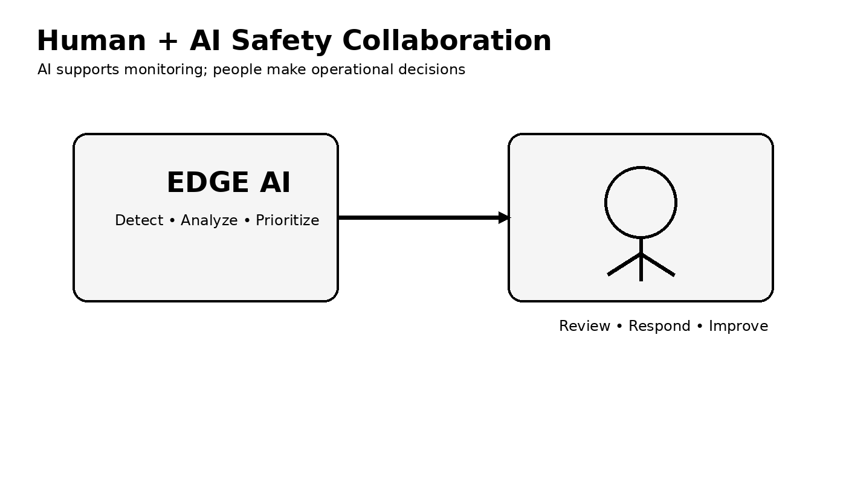
Figure 11.1 – Three Alternative Designs for the Same Insight

11.3 Trade-offs
The bar chart provides the strongest quantitative comparison because position and length are easy to compare against a common baseline. The donut/pie chart communicates part-to-whole composition but makes precise comparison harder. The ranked-bar alternative is compact and useful, but the primary bar view remains easier for exact comparison.

11.4 Justification of the Final Solution
The bar chart is selected as the most effective primary design for defect-category comparison because it minimizes cognitive effort and supports direct ranking. KPI cards provide rapid status awareness, while line charts and heatmaps support temporal and hotspot analysis. Multiple coordinated views are used instead of relying on a single chart type.

12. Broader Considerations / SDG Relevance

12.1 Broader Considerations
Safety and defect visualization can help users identify recurring hazards, quality issues, and operational hotspots. Real-world deployment would require validated computer-vision models, reliable camera/sensor data, documented provenance, cybersecurity, appropriate privacy safeguards, human oversight, and domain-expert review.

12.2 SDG Relevance
The project is relevant to SDG 9: Industry, Innovation and Infrastructure through intelligent industrial analytics and automation. It also connects to SDG 8: Decent Work and Economic Growth through workplace safety and productive industrial operations, and SDG 12: Responsible Consumption and Production through defect reduction and quality improvement.

13. Conclusion, Limitations and Possible Improvements

13.1 Conclusion
Edge Vision Guard demonstrates an interactive real-time-style safety and defect analytics system that combines structured event data, computer-vision-oriented monitoring, and perception-based visualization. Multiple views communicate operational status, defect distributions, severity, line and shift comparisons, temporal trends, relationships, and hotspots. The design comparison identifies the bar chart as the strongest primary view for accurate category ranking.

13.2 Limitations
• The supplied dataset is synthetic/educational rather than an official measured dataset.
• The dataset covers a fixed set of cities, years, and seasons.
• The analysis identifies associations but does not establish causal relationships.
• Missing values exist in PM10, Green Cover, and Humidity.
• The dashboard is an academic prototype and is not intended for clinical or regulatory decisions.
• Visualization effectiveness can vary with audience, screen size, and interaction context.

13.3 Possible Improvements
1. Replace the educational dataset with a validated open government or public-health dataset for real-world deployment.
2. Add more cities, geographic levels, and longer time periods.
3. Add geographic maps and spatial filtering.
4. Add data-quality indicators and preprocessing documentation.
5. Add parameter controls for metric selection and threshold analysis.
6. Conduct a user evaluation using task completion time and interpretation accuracy.
7. Improve accessibility using color-blind-safe palettes and alternative encodings.

14. Individual Contribution of Group Members
The project work was divided among the three group members, with all members participating in discussions, testing, dashboard refinement, and final report preparation.
Group Member | Contribution
Rakina S (192324289) | Dataset understanding, data preparation, and safety/defect distribution visualizations.
Harisha S (192324300) | Relationship, trend, production-line/shift visualizations, and dashboard arrangement.
Vaidyam Prasad Sneha (192324284) | Perception-based evaluation, design comparison, validation, result analysis, and report preparation.

15. References
1. Tableau, Tableau Desktop and Tableau visualization documentation.
2. Python Software Foundation, Python Documentation — supporting data-analysis concepts and dataset inspection.
3. DSA0601 – Data Handling and Visualization assignment instructions supplied for the project.
4. United Nations, Sustainable Development Goals.
5. Supplied dataset: Urban_Air_Quality_Public_Health_Visualization_Dataset.csv (educational/synthetic dataset created for visualization practice).

